

Schmalkalden University of Applied Sciences

**Master of Mechatronics and Robotics**

Project Report on **XY- Pen Plotter** under the subject of

**Workshop I & Ⅱ**

*Submitted by*

|  |  |
| --- | --- |
| **Name** | **Matriculation Number** |
| Parag Sudhir Sheth | 314983 |
| Onkar Vilas Repe | 315481 |
| Rohit Nitendra Acharekar | 315026 |
| Rahul Eknath Kadam | 315473 |
| Yash Sandesh Malwade | 315460 |

*Guided by*

**Prof. Dr. Ing. Stefan Roth**

University of Applied Sciences Schmalkalden Faculty of Mechanical Engineering

**Prof. Dr. Ing. Silvio Bachmann**

University of Applied Sciences Schmalkalden Faculty of Electrical Engineering

**Student Declaration**

We, **Parag Sudhir Sheth (314983), Onkar Vilas Repe (315481), Rohit Nitendra Acharekar (315026), Rahul Eknath Kadam (315473), Yash Sandesh Malwade (315460)** hereby declare that this project entitled **“XY PEN PLOTTER”** done by us under the guidance of **PROF. DR. STEFAN ROTH AND PROF. DR.-ING. SILVIO BACHMANN** is not copied and submitted anywhere for the award of any degree.

DATE:

PLACE: Schmalkalden, Germany

**PROJECT MEMBERS**

Parag Sudhir Sheth

Onkar Vilas Repe

Rohit Nitendra Acharekar

Rahul Eknath Kadam

Yash Sandesh Malawade

**Acknowledgement**

We would like to extend our heartfelt gratitude to Prof. Dr.-Ing. Silvio Bachmann and Prof. Dr. Stefan Roth for their invaluable guidance and unwavering support throughout the project. Their insightful suggestions, encouragement, and coordination played a pivotal role in shaping this dossier and ensuring its success. Additionally, we express sincere appreciation to our dedicated teachers whose teachings provided us with the necessary knowledge for this endeavour.

Furthermore, we are immensely grateful to all the individuals working in the AKT Lab. Their expertise, collaboration, and assistance were instrumental in the successful completion of our project. Their valuable contributions, coupled with the guidance of Prof. Dr.-Ing. Silvio Bachmann and Prof. Dr. Stefan Roth, have significantly enriched our project's outcomes.

We also extend our thanks to our classmates, whose interactions and inquiries enhanced our understanding of the subject matter. Their active involvement in the learning process has been truly valuable.

Lastly, we would like to thank the faculty, staff, and management for their assistance and provision of necessary resources that enabled us to bring this project to fruition. Their support has been crucial in our journey towards accomplishing our goals.

We express our sincere appreciation to all those who played a part in making this project a reality.

Table of Contents

List of Tables 4

List of Figures 5

Organisational Chart 6

CHAPTER 1A: INTRODUCTION 7

1.1 Task Description 7

1.1.2 Functions to be realized 7

1.2 V-Model approach used for this project 8

CHAPTER 1B: PROJECT BUILD-UP STAGES 9

CHAPTER 2: DESIGN 21

CHAPTER 3: MANUFACTURING AND ASSEMBLY 26

3.1 Manufacturing 26

3.2 Assembly 27

CHAPTER 4: ELECTRONICS AND PROGRAMMING 27

4.1 Hardware Components and their Functions 28

4.2 Software Features 29

4.3 Working Mechanism 29

4.4 Program Code with Explanation 30

CHAPTER 5: BILL OF MATERIALS AND FUTURE SCOPE 30

5.1 Bill of Materials 30

5.2 Future Scope 32

# List of Tables

Table 1 User Requirements 6

Table 2 Technical Specifications 9

Table 3 Design Specifications 11

Table 4 Verification Protocol 15

Table 5 Verification Report 16

Table 6 Validation Protocol 16

Table 7 Validation Report 17

Table 8 Design Description 18

Table 9 Characteristics of 3D Printer 23

Table 10 Hardware Specifications 25

Table 11 Motor and Pen plotter Movement 27

TABLE 12 BILL OF MATERIALS……………………………………………………………………………...28

# List of Figures

Figure 1 Organisational Chart 6

Figure 2: Project Goal 7

Figure 3 CREALITY (Ender-6) 3D-printer 26

Figure 4 Main Assembly 27

Figure 5 Working Mechanism 30

# Organisational Chart

We are a group of 5 students. Provided below is the organizational chart which explains the responsibilities taken by each of us individually.

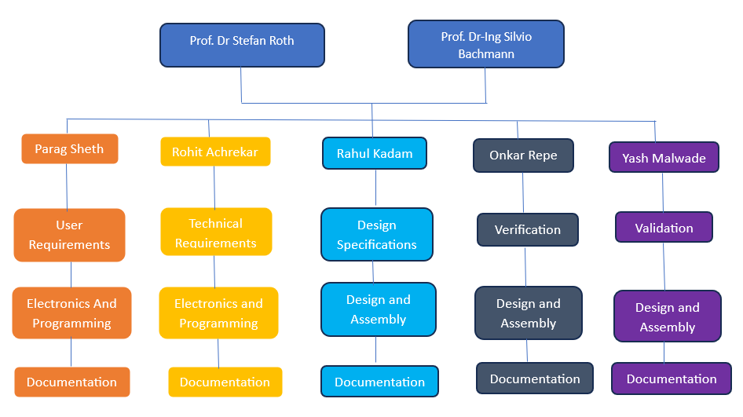

Figure 1 Organisational Chart

# CHAPTER 1A: INTRODUCTION

Our project titled: XY Pen plotter is a mechatronic device that can be used to draw in a 2D plane. It has two axes of motion, one in the X-direction and the other in Y-direction. The primary function is to draw Nikolaus’ House.

As the whole pen plotter assembly should be under 3.5 kg, parts were manufactured with the help of a 3-D printer. Parts printed in such manner were light-weight, economical, and easy to manufacture.

Further Use: By making appropriate modifications in some control parameters, the pen plotter can also draw designs according to the images fed to it.

## Task Description

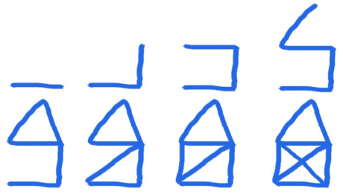

Figure 2: Project Goal

Our task is to design and program a XY pen plotter that can draw Nikolaus’ House.

### 1.1.2 Functions to be realized

* The assembly should have a pen holder.
* The plot area should be 100mm*100mm.
* The motion should be in X and Y directions.
* The left-hand corner position should be taken as reference (0,0).
* It should be programmable to draw Nikolaus’ House.

## V-Model approach used for this project

**Product (XY Pen Plotter)**

* System checking.
* XY pen plotter operating procedure validation
* Test protocol.

**System Testing**

* The code should be easy to maintain and efficient.
* Electronic components test

**Test report**

* Cycle time to draw is less than 50 seconds.
* No error in electrical connections and in assembly.



**Technical Specifications**

* The pen plotter operating system uses ESP32 and a Qwiic motor driver.
* Should take less than 50 seconds to complete one cycle.



**User Requirements:**

The XY pen plotter should be able to draw Nikolaus’ House.



**Software requirements**

* Programming of Arduino UNO
* Use Solidworks for designing parts.

**Verification of design**

* Verify the printed parts and fit them into the assembly.
* Weigh individual parts as well as the whole assembly.



**System integration**

* Verification of hardware connection and rotation of drives (Bi-directional).
* Limit switches and emergency stop testing.



**Implementation**

* All of the parts are printed using additive manufacturing technology.
* Coordinating mechanical and electrical parts to get the necessary system (Core XY mechanism).
* Coding the microcontroller to get the necessary result (Nikolaus’ House).

**Electrical Requirements**

* Use DC motors and ESP32 to control.
* Limit switches, and motor drivers have to be used.

**Mechanical Requirements**

* XY-plotter components are manufactured using the 3D printing technique.
* Use the given shafts, bearings, and base plate.

# CHAPTER 1B: PROJECT BUILD-UP STAGES

As a part of any project, we need to first list down the user requirements. They provide a framework for the entire product development process and define the market's current requirements. Hence, prior to beginning work on this project, we were required to compile a list of potential user requirements for the product's technical, functional, and safety requirements using the project guidelines.

We have written the user requirements in an excel sheet format as listed below,

Table 1 User Requirements

|  |  |  |  |  |  |
| --- | --- | --- | --- | --- | --- |
| **USER REQUIREMENTS** | | | | | |
| **UR#** | **Title** | **User Requirement** | **Remark** | **Domain (MECH/SW/HW)** | **Mandatory / Recommended** |
| **Application** | | | | | |
| UR1 | Intended Use | A 2D pen plotter designed to draw a Nicolas House with help of programming which can be used by students in university laboratory for educational purposes only. |  | GENERAL | Mandatory |
| UR2 | Use Case | To be able to draw the Nicolas House |  | GENERAL | Mandatory |
| UR3 | Focus Group | University Students (Age: 20 to 30 years) |  | GENERAL | Mandatory |
| UR4 | Site of Application | For indoor use only. |  | GENERAL | Mandatory |
| **General** | | | | | |
| UR5 | Portability | No extra assembly should be required and should be easy to carry |  | MECH | Mandatory |
| UR6 | Dimensions | The assembly should fit inside a box |  | MECH | Mandatory |
| UR7 | Weight | The entire assembly should be light weight |  | MECH | Recommended |
| UR8 | Robust Body | The body should be robust and withstand fall from small heights |  | MECH | Recommended |
| UR9 | Service Life | Lifetime of at least 100 cycles of Nikolaus’ house |  | MECH | Recommended |
| **Base Plate Module** | | | | | |
| UR10 | Thickness | Should support papers of standard thickness |  | GENERAL | Recommended |
| UR11 | Dimensions | Should support papers of standard sizes |  | GENERAL | Recommended |
| UR12 | Support | The base plate should support and house all the components |  | MECH | Mandatory |
| UR13 | Fixture | The base plate should have fixtures to hold the paper tightly |  | MECH | Recommended |
| **Power Supply Module** | | | | | |
| UR14 | Power Supply | Li-ion batteries can be used | 3.7V | HW | Mandatory |
| UR15 | Power Supply | USB port for operating power |  | HW | Mandatory |
| UR16 | Charging Cable | No requirement of charging plug for entire pen plotter assembly. |  | HW | Mandatory |
| UR17 | Module | Breadboard power supply module to be used. |  | HW | Mandatory |
| **Pen Holder Module** | | | | | |
| UR18 | Size | Pen of not more than 15mm diameter should be used. | Pen diameter<=15mm | MECH | Mandatory |
| UR19 | Grip | The pen should have a good grip so that its movement is restricted |  | MECH | Recommended |
| UR20 | Usability | Any pen should be easily replaceable within the penholder |  | GENERAL | Mandatory |
| UR21 | Holder Characteristics | Drawing on board with up to thickness of 5cm should also be possible. | Drawing medium<=5cm | GENERAL | Recommended |
| UR22 | Holder Characteristics | Pencils should be also usable |  | GENERAL | Recommended |
| **User Interface Module** | | | | | |
| UR23 | Ease of Use | Easy to use UI on the mobile App which can control the pen plotter parameters |  | SW | Recommended |
| UR24 | Connectivity | Should have good connectivity |  | SW | Mandatory |
| UR25 | Alarm Recognition | Should be able to show warnings and failures |  | SW | Mandatory |
| UR26 | Accessibility | Should be flexible and be easy in setting the set points |  | SW | Recommended |
| **Safety Module** | | | | | |
| UR27 | Operate within limit | The pen plotter should work only within the designated limits |  | SW | Recommended |
| UR28 | Emergency Stop | Should incorporate emergency stop |  | SW | Mandatory |
| UR29 | Alarm | Should raise alarms and notify the user in case of failure |  | SW | Recommended |
| **Control Module** | | | | | |
| UR30 | Programming | Arduino IDE should be used for programming of ESP32 |  | SW | Mandatory |
| UR31 | Control features | Should only use breadboard for circuit implementation |  | SW | Mandatory |
| UR32 | Control Features | Should use control points like- Start, Calibration and Emergency Stop. |  | SW | Mandatory |
| UR33 | Accessibility | Integration of User Interface for handling parameters using Wi-Fi connection |  | SW | Recommended |
| **Drive Unit Module** | | | | | |
| UR34 | Movement Speed | Pen movement should be possible at different speed |  | MECH | Recommended |
| UR35 | Accuracy | Actuator should provide precise movement |  | HW |  |
| UR36 | Motors | DC motors needs to be used for 2 axes |  | HW | Mandatory |
| UR37 | Drawing capability | In a 2D plane, a pen should be able to draw lines at any angle |  | GENERAL | Recommended |
| **Linear Movement Module** | | | | | |
| UR38 | Vibrations | Should have less Vibrations |  | MECH | Mandatory |
| UR39 | Linear Movement Characteristics | Linear ball bearing with shafts should be used |  | HW | Recommended |
| UR40 | Linear Movement Characteristics | Belt drive system should have appropriate pitch | Approx. 2mm | MECH | Recommended |
| UR41 | Friction | Less frictional contacts points |  | MECH | Mandatory |
| UR42 | Limit switches | Use limit switches to detect the end & start positions |  | HW | Mandatory |
| **Sliders/Rolls Module** | | | | | |
| UR43 | Rods/Sliders | Standard rods and sliders to be used. |  | MECH | Mandatory |
| UR44 | Assembly | Assembly should have minimal weight in total |  | GENERAL | Recommended |
| UR45 | Characteristics | Sliding surfaces should make low noise. |  | GENERAL | Recommended |
| UR46 | Hardware | Standard bearings and pulleys must be used. |  | MECH | Mandatory |
| **Frame** | | | | | |
| UR47 | Frame Characteristics | Frame should be rigid and should not bend. |  | MECH | Mandatory |
| UR48 | Frame Characteristics | Should be light weight and designed optimally. |  | MECH | Recommended |
| UR49 | Hardware | Standard mechanical parts should be used. |  | MECH | Mandatory |
| UR50 | Hardware | No fixtures should be necessary before using pen plotter. |  | MECH | Mandatory |
| **Commercial Requirements** | | | | | |
| UR51 | Components Allotment | All the needed components are provided by the university |  | MECH | Mandatory |
| UR52 | Extra Components | Extra components if used, it should be standardized |  | GENERAL | Recommended |
| **Regulatory Requirements** | | | | | |
| UR53 | Accident Prevention | Provision for Emergency Stop should be available. |  | HW | Mandatory |
| UR54 | CE Conformity | Device has to be designed according to corresponding standards for safety. |  | GENERAL | Mandatory |
| UR55 | Wiring | All wires must be properly insulated. |  | HW | Mandatory |

Technical Specifications are derived on the basis of user requirements as shown below,

Table 2 Technical Specifications

|  |  |  |  |  |  |  |
| --- | --- | --- | --- | --- | --- | --- |
| **Technical Specification** | | | | | | |
| **TS#** | **Reference to UR#** | **Technical Requirement** | **Remark** | **Domain** | **Mandatory / Recommended** |  |
| **Application** | | | | | | |
| TS1 | UR1 | A 2D pen plotter designed to draw a Nicolas House with help of programming which can be used by students in university laboratory for educational purposes only. |  | GENERAL | Mandatory | |
| TS2 | UR2 | To be able to draw the Nicolas House |  | GENERAL | Mandatory | |
| TS3 | UR3 | University Students (Age: 20 to 30 years) |  | GENERAL | Mandatory | |
| TS4 | UR4 | For indoor use only. |  | GENERAL | Mandatory | |
| **General** | | | | | | |
| TS5 | UR5, UR12 | All structures will be fixed and enclosed on the board |  | MECH | Recommended | |
| TS6 | UR6 | Maximum dimension of box 560x390x420 mm |  | MECH | Mandatory | |
| TS7 | UR7 | Maximum weight of 3.5 kg |  | MECH | Mandatory | |
|  |  |  |  |  |  | |
| TS8 | UR9 | Battery with 1300 mAh is used |  | HW | Mandatory | |
| **Base Plate Module** | | | | | | |
| TS9 | UR10. UR13 | Paper up to 5mm thickness can be used. Size of the paper from 10x10 cm up to A4 can be used. The board has fixtures to prevent undesired movement of paper |  | GENERAL | Recommended | |
| TS10 | UR11 | Base Plate dimensions are 305 x 305 x 15 mm |  | GENERAL | Mandatory | |
|  |  |  |  |  |  | |
|  |  |  |  |  |  | |
| **Power Supply Module** | | | | | | |
| TS11 | UR14 | Li-ion Battery of 3.7V, 1300mAh, 4.81wh is used |  | HW | Mandatory | |
|  |  |  |  |  |  | |
|  |  |  |  |  |  | |
| TS12 | UR15, UR16, UR17 | Breadboard power supply TS1171 is used |  | HW | Mandatory | |
| **Pen Holder Module** | | | | | | |
| TS13 | UR18 | Inner diameter of penholder is 15mm |  | MECH | Mandatory | |
| TS14 | UR19 | Rubber grip can be used for the pen |  | MECH | Recommended | |
| TS15 | UR20, UR22 | Use of screwing mechanism to adjust the thickness of penholder |  | GENERAL | Mandatory | |
|  |  |  |  |  |  | |
|  |  |  |  |  |  | |
| **User Interface Module** | | | | | | |
| TS16 | UR23, UR25, UR26 | Easy to read dashboard on the mobile application with user friendly design. Supported with Alarm indicators. |  | SW | Recommended | |
| TS17 | UR24 | Wi-Fi connection is used |  | SW | Recommended | |
|  |  |  |  |  |  | |
|  |  |  |  |  |  | |
| **Safety Module** | | | | | | |
| TS18 | UR27, UR42 | Hardware interlock with limit switches is used to operate within limits |  | HW | Recommended | |
|  |  |  |  |  |  | |
|  |  |  |  |  |  | |
| **Control Module** | | | | | | |
| TS19 | UR30 | Thing Plus ESP32 is used |  | SW | Mandatory | |
| TS20 | UR31 | Breadboard Power Supply TS1171 is used |  | SW | Mandatory | |
| TS21 | UR32 | Use Emergency stop button |  | HW | Mandatory | |
| TS22 | UR33 | Wi-Fi connection is used |  | SW | Recommended | |
| **Drive Unit Module** | | | | | | |
| TS23 | UR34 | motor speed is varied by Motor driver |  | MECH | Recommended | |
| TS24 | UR35, UR40 | Accurately designed gears and timing belt |  | MECH | Mandatory | |
| TS25 | UR36 | DC Geared motor of 4.5V & 48:1 gear ratio is used |  | HW | Mandatory | |
|  |  |  |  |  |  | |
| **Linear Movement Module** | | | | | | |
| TS26 | UR38 | The motor and belt pulley mechanism is rigid and sturdy |  | HW | Recommended | |
| TS27 | UR41, UR45 | LMU-N6 Linear ball bearing and d6 x 300mm Shafts are used |  | MECH | Mandatory | |
| TS28 | UR40 | pitch of belt is 2mm and 6mm wide |  | MECH | Mandatory | |
|  |  |  |  |  |  | |
| TS29 | UR42 | 4 XSS-5GL 13 limit switches are used for 2 axes |  | HW | Mandatory | |
| **Sliders/Rolls Module** | | | | | | |
| TS30 | UR43, UR45, UR46 | LMU-N6 linear bearings along with 6mm stainless steel shafts are used for smooth movement |  | MECH | Mandatory | |
|  |  |  |  |  |  | |
|  |  |  |  |  |  | |
|  |  |  |  |  |  | |
| **Frame** | | | | | | |
| TS31 | UR44, UR46, UR47 | ABS plastic with sturdy design is used |  | MECH | Mandatory | |
|  |  |  |  |  |  | |
| TS32 | UR49 | Parts are 3D printed according to standards |  | MECH | Mandatory | |
|  |  |  |  |  |  | |
| **Commercial Requirements** | | | | | | |
|  |  |  |  |  |  | |
|  |  |  |  |  |  | |
| **Regulatory Requirements** | | | | | | |
| TS33 | UR53 | A Kill switch is provided for emergency stop |  | HW | Mandatory | |
| TS34 | UR54 | The device has to be designed according to machinery device directive 2006/42/EC. |  |  |  | |
| TS35 | UR55 | Heat Shrink / Wire cover is used |  | HW | Recommended | |

On basis of the above Technical Specifications, we have derived the following design specifications:

Table 3 Design Specifications

|  |  |  |  |  |  |  |
| --- | --- | --- | --- | --- | --- | --- |
| **Design Specifications** | | | | | | |
| **DS#** | **Ref to TS#** | **Reference (#bill of materials, article # supplier part, ref. doc# etc..) to implementation** | **Description** | **Remark** | **Domain (HW, SW, ME, All)** | |
| **Application** | | | | | | |
|  |  |  |  |  |  | |
|  |  |  |  |  |  | |
|  |  |  |  |  |  | |
|  |  |  |  |  |  | |
| **General** |  |  |  |  |  |  |
|  |  |  |  |  |  | |
| DS2 | TS6 | Bill of material (Doc# 001- XY_Pen_Plotter_Group 7_BOM.docx) | The maximum dimensions of assembly are 305x305x115 mm |  | General | |
| DS3 | TS7 |  | The entire assembly weighs 2.8kgs. |  | General | |
|  |  |  |  |  |  | |
| DS4 | TS8 | Bill of material (Doc# 001- XY_Pen_Plotter_Group 7_BOM.docx) | 1300mAh battery is used. |  | HW | |
| **Base Plate Module** |  |  |  |  |  |  |
| DS5 | TS9, TS10 | Bill of material (Doc# 001- XY_Pen_Plotter_Group 7_BOM.docx) | The whole assembly is mounted on area of 305x305 mm wooden board. Sketch area is 100x100 mm. |  | General | |
|  |  |  |  |  |  | |
|  |  |  |  |  |  | |
|  |  |  |  |  |  | |
| **Power Supply Module** |  |  |  |  |  |  |
| DS6 | TS11 | SparkFun | Sparkfun 1300mAh 3.7V battery is used to power the drive motor. |  | HW | |
|  |  |  |  |  |  | |
|  |  |  |  |  |  | |
|  |  |  |  |  |  | |
| **Pen Holder Module** |  |  |  |  |  |  |
| DS7 | TS13, TS15 | Bill of material (Doc# 001- XY_Pen_Plotter_Group 7_BOM.docx) | Penholder with maximum 15mm inner diameter is designed. A screwing mechanism is added to the design to adjust the thickness. |  | Mech | |
|  |  |  |  |  |  | |
|  |  |  |  |  |  | |
|  |  |  |  |  |  | |
|  |  |  |  |  |  | |
| **User Interface Module** |  |  |  |  |  |  |
| DS8 | TS16 | A Webpage designed for Control functions: [https://192.168.1.1](https://192.168.1.1/) | A simple dashboard with 4 arrow keys for manual control, Auto/ Manual Switch and Start Button. The design is based on dark theme, |  | SW | |
| DS9 | TS17 |  | A static Wifi Address is assigned to the controller and is connected using an Android App for controlling and monitoring. |  | SW | |
|  |  |  |  |  |  | |
|  |  |  |  |  |  | |
| **Safety Module** |  |  |  |  |  |  |
| DS10 | TS18 | Bill of material (Doc# 001- XY_Pen_Plotter_Group 7_BOM.docx) | XSS-5GL 13 limit switch is used to sketch within the limits. |  | HW | |
| DS11 | TS21 | Bill of material (Doc# 001- XY_Pen_Plotter_Group 7_BOM.docx) | The plotter can be stopped manually using the Emergency switch in the event of any system emergencies. |  | HW | |
|  |  |  |  |  |  | |
| **Control Module** |  |  |  |  |  |  |
| DS12 | TS12, TS19, TS20, TS22 | Bill of material (Doc# 001- XY_Pen_Plotter_Group 7_BOM.docx) | TS1171 Breadboard with 165x60 mm dimensions is used. ESP32 and all electrical components used to control the mechanism are mounted on it. |  | HW | |
|  |  |  |  |  |  | |
|  |  |  |  |  |  | |
|  |  |  |  |  |  | |
| **Drive Unit Module** |  |  |  |  |  |  |
| DS13 | TS23 | SparkFun | A QWIIC motor driver is used which can control the motor speed and direction. |  | HW | |
| DS14 | TS24 | Bill of material (Doc# 001- XY_Pen_Plotter_Group 7_BOM.docx) | 15 teethed pulley is used with 2mm pitch along with 2mm pitch belt for accurate control of motion. |  | Mech | |
| DS15 | TS25 | SparkFun | DAGU DG01D 48:1 motor is used. |  | HW | |
|  |  |  |  |  |  | |
| **Linear Movement Module** |  |  |  |  |  |  |
| DS16 | TS26, TS28 | Timing Belt | The mechanism is based on CoreXY mechanism which is accurate. Using 10 pulleys and 2mm pitch belts, we get sturdy design and force on each individual component is reduced. |  | Mech | |
| DS17 | TS27 | Misumi shafts and LMU-N6 bearings | The LMU N6 Linear ball bearing are assembled with tight fit in the parts which moves on cylindrical rods which provide linear movement in the mechanism. |  | Mech | |
|  |  |  |  |  |  | |
|  |  |  |  |  |  | |
|  |  |  |  |  |  | |
| **Sliders/Rolls Module** |  |  |  |  |  |  |
| DS18 | TS30 | Misumi shafts and LMU-N6 bearings | d6x300 mm shafts with LMU-N6 linear bearings of outer diameter 12mm are used for smooth movement of the mechanism. |  | Mech | |
|  |  |  |  |  |  | |
|  |  |  |  |  |  | |
|  |  |  |  |  |  | |
| **Frame** |  |  |  |  |  |  |
| DS19 | TS30 | Solidworks | Components are designed using SolidWorks. |  | SW | |
| DS20 | TS31 | 3D-Printer: Creality Ender 6 | All the parts are manufactured using additive manufacturing. |  | Mech | |
|  |  |  |  |  |  | |
|  |  |  |  |  |  | |
| **Commercial Requirements** |  |  |  |  |  |  |
|  |  |  |  |  |  | |
|  |  |  |  |  |  | |
| **Regulatory Requirements** |  |  |  |  |  |  |
| DS21 | TS33 | EU Standards | All the measurements follow the EU standards. |  | General | |
|  |  |  |  |  |  | |
|  |  |  |  |  |  | |

The mechanism working and control system was verified and validated as follows:

**Verification Protocol:**

Table 4 Verification Protocol

|  |  |  |  |  |  |
| --- | --- | --- | --- | --- | --- |
| Verification Protocol | | | | | |
| VerP # | Ref to TS# | Test Procedure (description of routine) | Verification Criterion | ref. # (i.e. test protocol, etc) | Domain (HW/SW/ME/All) |
| Application | | | | | |
| VerP1 | TS2 | Setup pen plotter on a stable surface. Then it should be able to draw Nikolaus house. | Should have straight lines and be able to draw Nikolaus’ House. | Doc# 002- Verification and Validation.docx | ALL |
| VerP2 | TS2 | Draw the Nikolaus House with good repeatability | Draw the Nikolaus House 3 times continuously. | Doc# 002- Verification and Validation.docx | ME |
| General Functions | | | | | |
| VerP3 | TS6 | Put the pen plotter into a box of 56x39x42 cm provided by Uni Lab. | Fits in the box with lid closed. | Doc# 002- Verification and Validation.docx | HW |
| VerP4 | TS7 | Place the pen plotter assembly on a measuring scale with an accuracy of ± 1gm. Take 3 readings and find out their mean value. | Mean of three weight measurement is well below 3500gm | Doc# 002- Verification and Validation.docx | HW |
| Pen Holder | | | | | |
| VerP5 | TS13 | Gather pens, position them and measure the diameter by Vernier caliper. Record the measurement results for each pen. | The diameter is less than 15mm | Doc# 002- Verification and Validation.docx | ME |
| Safety | | | | | |
| VerP6 | TS18 | Confirm switch functionality when contacted by levers, preventing overtravel and ensuring accurate and safe plotting. Check 5 times. | Overtravel prevention, accurate and safe plotting. | Doc# 002- Verification and Validation.docx | HW |
| Control | | | | | |
| VerP7 | TS21 | In case of device malfunction, an Emergency Stop push button switch is provided. | A push button immediately ceases the operation and stops the operation | Doc# 002- Verification and Validation.docx | HW |
| Regulatory | | | | | |
| VerP8 | TS34 | CE conformity assessment to be carried out with respect to machinery device directive 2006/42/EC. | CE assessment done | Doc# 002- Verification and Validation.docx | ALL |

**Verification Report:**

Table 5 Verification Report

|  |  |  |  |  |  |  |
| --- | --- | --- | --- | --- | --- | --- |
| Verification Report | | | | | | |
| VerR # | ref to VerP # | Test Function (to be copied from Verification protocol) | Nominal Criterion, the target value | Actual value | Criterion passed/ failed | Domain (HW/SW/ME/All) |
| Application | | | | | | |
| VerR1 | VerP1 | To draw a Nicholas Hause | Hause should have straight lines | Is having straight lines | Passed | ALL |
| VerR2 | VerP2 | Draw the Nikolaus House with good repeatability | Repeatable Drawing for 3 cycles | Good Repeatability for 3 Cycles | Passed | ME |
| General Functions | | | | | | |
| VerR3 | VerP3 | To put the pen plotter into a box of 56x39x42 cm^3 provided by Uni Lab. | Fits in box with lid closed | Fits perfectly | Passed | HW |
| VerR4 | VerP4 | To ensure that pen plotter assembly weighs less than 3.5 kgs. | Weight <= 3.5kg |  | Passed | HW |
| Pen Holder | | | | | | |
| VerR5 | VerP5 | Maximum pen diameter used is less than or equal to 15mm | Diameter <=15mm | 13mm | Passed | ME |
| Safety | | | | | | |
| VerR6 | VerP6 | Confirm switch functionality when contacted by levers, preventing overtravel and ensuring accurate and safe plotting. Check 5 times. | Accurate functionality and safe plotting | All the switches work properly. | Passed | HW |
| Control | | | | | | |
| VerR7 | VerP7 | In case of device malfunction, an Emergency Stop push button switch is provided. | Stop the system in less than 1 sec. | System stopping time < 1sec. | Passed | HW |

**Validation Protocol:**

Table 6 Validation Protocol

|  |  |  |  |  |
| --- | --- | --- | --- | --- |
| **Validation Protocol** | | | | |
| **ValP #** | **ref. to UR #** | **Validation procedure( description of routine)** | **ref. # (i.e.  validation  protocol, customer test, etc..)** | **validation criterion, target value** |
| ValP1 | UR1,UR2,UR4 | Set-up pen plotter at the university's lab, start pen plotter by student, draw Nikolaus haus. | Doc# 002- Verification and Validation.docx | Plotter must draw Nikolaus house in one run. |
| ValP2 | UR6 | Put the pen plotter into a box of 56x39x42 cm provided by Uni Lab. | Doc# 002- Verification and Validation.docx | Fits perfectly |
| ValP3 | UR7 | Place the pen plotter assembly on a measuring scale with an accuracy of ± 1gm | Doc# 002- Verification and Validation.docx | Total weight <= 3.5kg |
| ValP4 | UR9 | Draw the Nikolaus House with good repeatability | Doc# 002- Verification and Validation.docx | 3 Times |
| ValP5 | UR27, UR42 | Verify switch functionality by testing 5 times, ensuring successful halting of plotter movement upon contact with levers, preventing overtravel and ensuring accurate and safe plotting. | Doc# 002- Verification and Validation.docx | All the switches work properly. |
| ValP 6 | UR18 | Maximum pen diameter of 15mm | Doc# 002- Verification and Validation.docx | Pen diameter <=15mm |
| ValP 7 | UR28 | Perform testing of emergency stop and checking for any errors. | Doc# 002- Verification and Validation.docx | Emergency Stop button works properly |

**Validation Report**

Table 7 Validation Report

|  |  |  |  |
| --- | --- | --- | --- |
| **Validation Report** | | | |
| **ValR #** | **ref. to ValP #** | **criteria (passed/failed)** | **ref. # (i.e. test report, etc..)** |
| ValR1 | ValP1 | Passed | Doc# 002- Verification and Validation.docx |
| ValR2 | ValP2 | Passed | Doc# 002- Verification and Validation.docx |
| ValR3 | ValP3 | Passed | Doc# 002- Verification and Validation.docx |
| ValR4 | ValP4 | Passed | Doc# 002- Verification and Validation.docx |
| ValR5 | ValP5 | Passed | Doc# 002- Verification and Validation.docx |
| ValR6 | ValP 6 | Passed | Doc# 002- Verification and Validation.docx |
| ValR7 | ValP 7 | Passed | Doc# 002- Verification and Validation.docx |

# 

# CHAPTER 2: DESIGN

Summary: This chapter provides brief information about CAD-design used for our project.

Solidworks 2022 was used to convert our design ideas to the physical world. Our design phase consisted of three phases namely, Ideation, Prototyping and then validation. Our main motive for design was to create a product and not a mere project. We chose core-xy movement as our basis as we wanted 2 axis movement in our pen plotter.

Elaborating more on phases. Ideation as the name suggests is a stage where we as a group jotted down every idea, we had about pen plotter. How should it look? What principles should we use? What parts to be printed? Efficiency? Feasibility? were some of the questions we tackled in that phase. At the end of that week, we had answers to most of the questions which gave us a rough sketch of what our end product will look like.

After our first design we sent all the parts to 3D print, to create our first prototype. Believe it or not we had 50 new design faults or problems which we had to rectify and make our final design with taking everything into consideration. A little tiring process but a really important one to get a good end product. That's what Prototyping is for. Once our Main design was ready, we again printed all the parts for validation and testing. The test code for basic movements was running smoothly on our first assembly of parts itself.

Below you will find every Mechanical part that is used in our Plotter, you can see its design and understand how and what it does.

Table 8 Design Description

|  |  |
| --- | --- |
| PARTS | DESCRIPTION |
|  | **Main Support 1:**  It’s the first half of main support. This is responsible for holding the penholder and also provide means to translate it in X – Direction. It has means to hold 2 bearings which allows entire support to translate in Y – Direction. |
|  | **Main Support 2:**  It’s the second half of main support. This is responsible for holding the penholder and also provide means to translate it in X – Direction. It has means to hold 2 bearings which allows entire support to translate in Y – Direction. |
|  | **Main Support End:**  Acts a closure at the end of Main Support, it has 2 indents to hold the shafts in place. |
|  | **Side Support Left 1:**  It’s the first half of Left support. This is responsible for holding the main support and also provide means to translate it in Y – direction. It had protrusions to hold shaft on which the main support moves. This is where the Motor is mounted. |
|  | **Side Support Left 2:**  It’s the second half of Left support. This is responsible for holding the main support and also provide means to translate it in Y – direction. It had protrusions to hold shaft on which the main support moves. Also, there’s a guide pulley structure provided on it. |
|  | **Side Support Right 1:**  It’s the first half of Right support. This is responsible for holding the main support and also provide means to translate it in Y – direction. It had protrusions to hold shaft on which the main support moves. Also, there’s a guide pulley structure provided on it. |
|  | **Side Support Right 2:**  It’s the second half of Right support. This is responsible for holding the main support and also provide means to translate it in Y – direction. It had protrusions to hold shaft on which the main support moves. This is where the second Motor is mounted. |
|  | **Main Pulley:**  This pulley mainly acts a guide pulley for the belt. Helping in transmitting the power generated from the motor. It is designed to fit onto the guide pulley structure on Side Supports. |
|  | **Motor Pulley:**  Motor pulley transmits the power generated from motor to belt. It has a cap like structure at the top to stop or prevent any belt slippage. It has a motor groove below which fits like a sleeve on motor. |
|  | **Pulley Cap:**  Its an intermediate part between guide pulley structure and 2 pulleys. It provides means to mount two pulleys on top of each other without fixing them or constricting its rotation. |
|  | **Pulley End Cap:**  Closure for the pulley structure. Makes sure the entire structure is in position and fastened. |
|  | **Pen Holder:**  As the name suggests it’s the Pen holder. A small screw is provided to tighten the Pen in its position and can accompany pens of varied Diameters. It has provision to hold 2 bearings which allows it to translate in X – Direction. It has Extrusions on top where all the belts are attached. |
|  | **Box:**  A basic box acting as an enclosure for all our electrical components and wiring. Made to look clean and aesthetic as opposed to messy wiring system. |
|  | **Cover:**  A basic cover for the aforementioned box. Helps as a simple cover. No fasteners just simple pick and place design for ease. |

# CHAPTER 3: MANUFACTURING AND ASSEMBLY

Summary: This chapter focuses on method of manufacturing the XY pen plotter components. Also, it gives step-wise information about assembling the whole mechanism.

## 3.1 Manufacturing

We have used CREALITY (Ender-6) 3D-printer with a print precision of ± 0.1mm. 3D Printing is an easy and safe way to manufacture complex components. To manufacture the parts, first we need to convert the file to .STL extension. This file format is supported by many other software packages; it is widely used for rapid prototyping, 3D printing and computer-aided manufacturing. STL files describe only the surface geometry of a three-dimensional object without any representation of colour, texture of other common CAD model attributes.

This printer required a CAD file of STL extension. These files are commonly used for 3D printing and CAD.

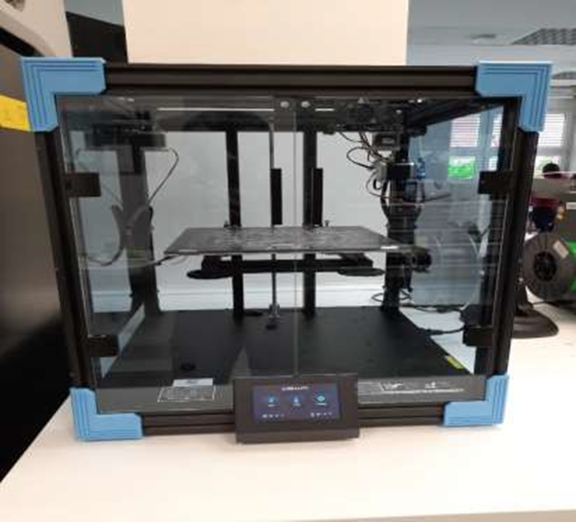

Figure 3 CREALITY (Ender-6) 3D-printer

Table 9 Characteristics of 3D Printer

|  |  |
| --- | --- |
| Characteristics of CREALITY (Ender-6) 3D-printer | |
| 3D Printer (WxDxH) | 495x495x650mm |
| Weight | 22 kg |
| Build Volume | 250*250*400 mm |
| Materials | PLA/TPU/Wood/Carbon Fiber |
| Technology Used | FDM (Fused Deposition Modelling) |
| Layer Resolution | ±0.1mm |
| Touch-Screen | 4.3 inch |
| Layer Height | 0.1-0.4 mm |
| Print Mode | SD Card |

## 3.2 Assembly

Step 1: Fix the position of mounting holes on the wooden board and drill accordingly.

Step 2: Fix the right and left side supports on the wooden board.

Step 3: Fit all the bearings on main support part and penholder.

Step 4: Put the rods through the bearings and fix them on the side supports.

Step 5: Insert the pen holder in the main support and close the main support with the end plate

Step 6: Mount the motors and all the pulleys on both the side supports and main support.

Step 7: Winding the timing belt along all pulleys and fix and tighten it at the pen holder.

Step 8: Place the pen in the pen holder.

Step 9: Make all the electrical connections and load the program

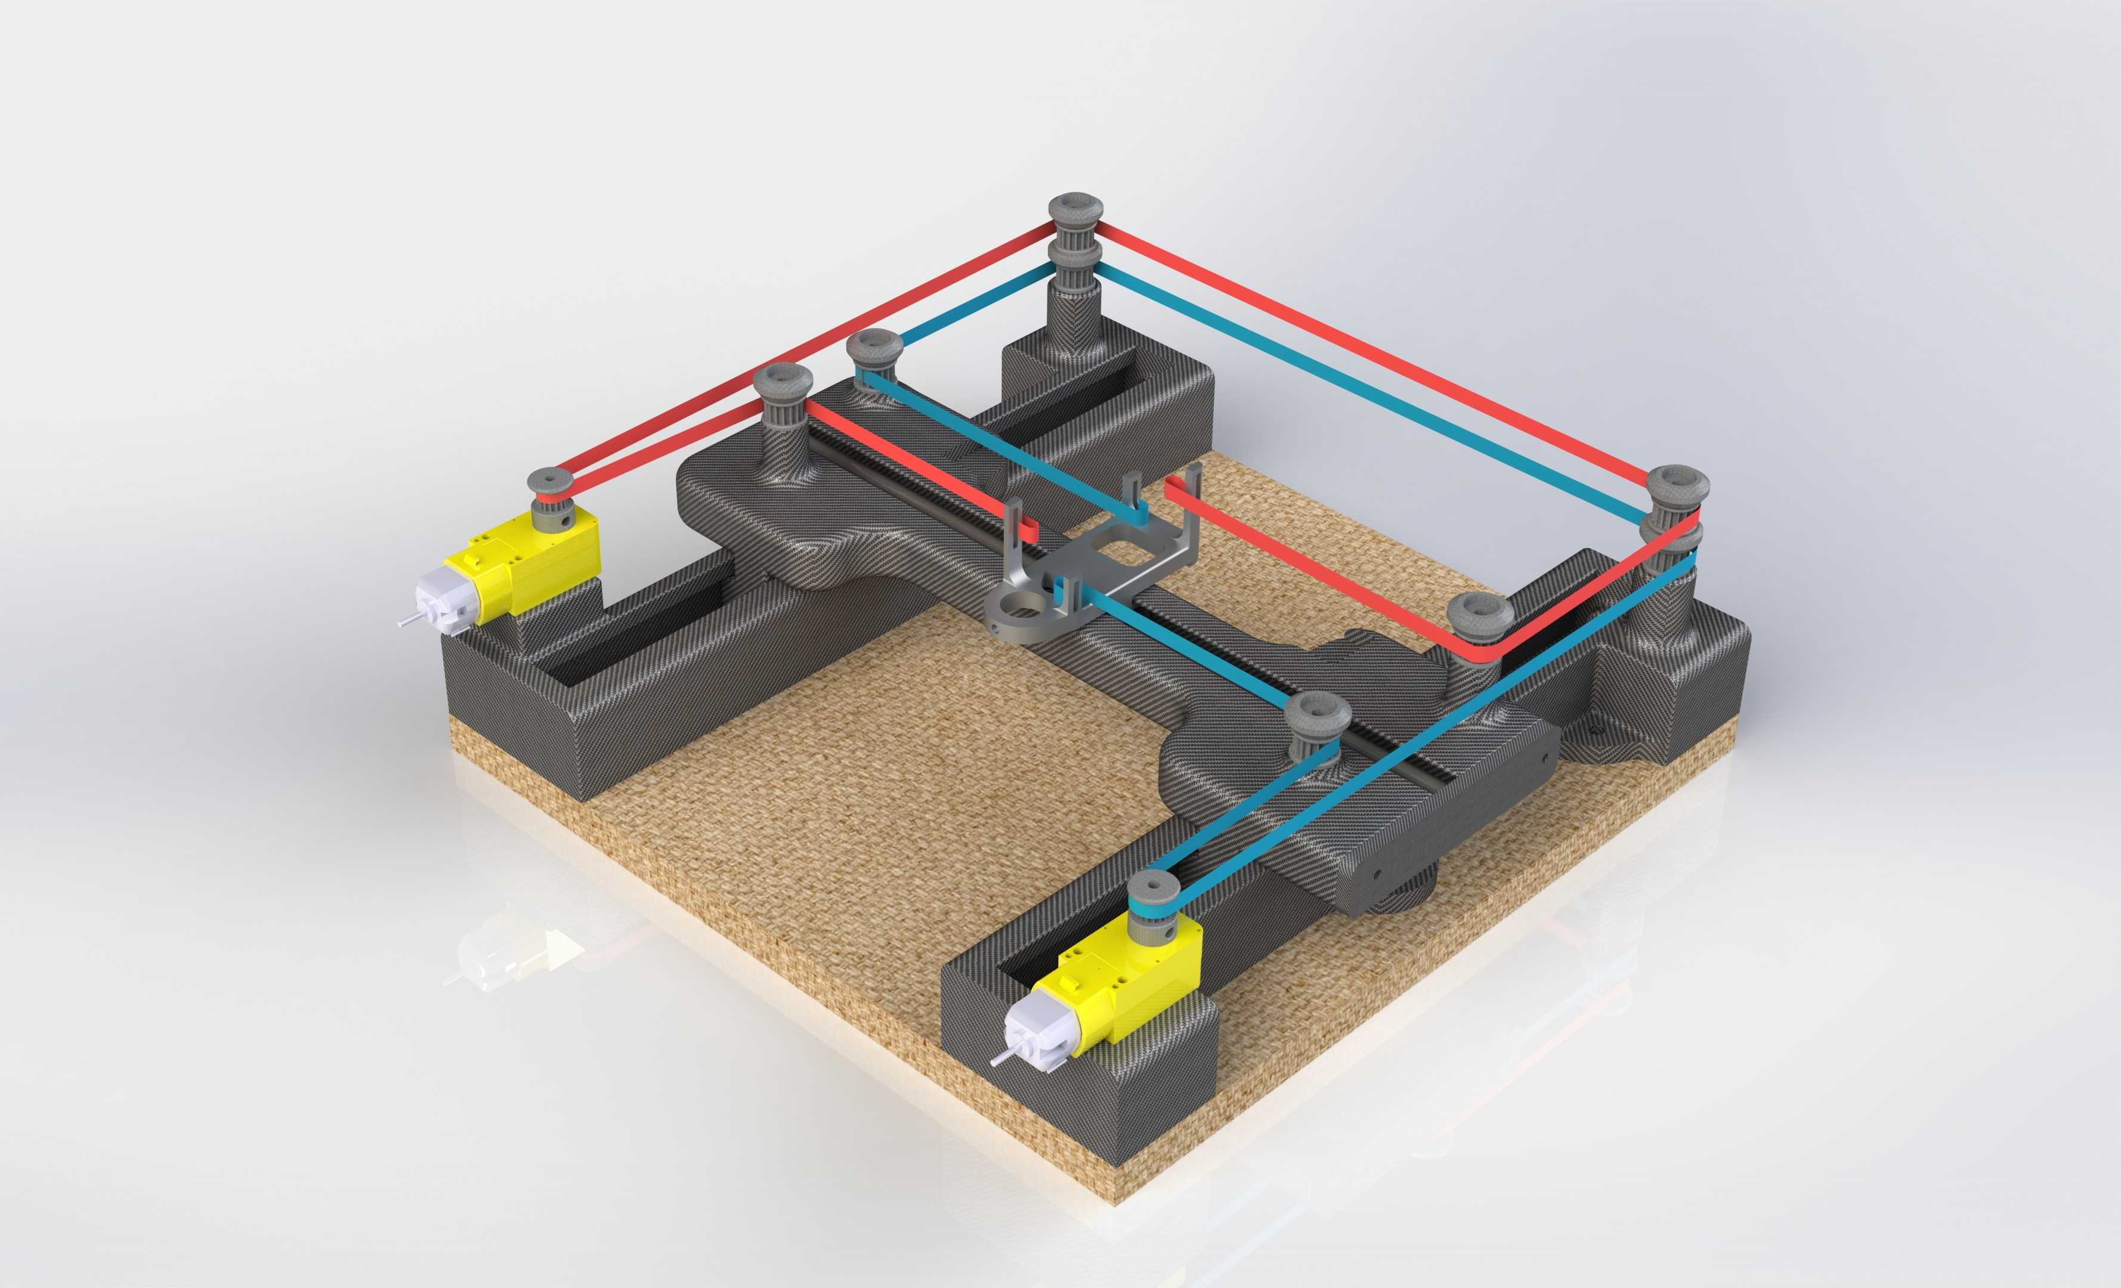

Figure 4 Main Assembly

# CHAPTER 4: ELECTRONICS AND PROGRAMMING

Summary: This chapter provides in depth information regarding Electronics and Programming phase of the project.

## 4.1 Hardware Components and their Functions

Table 10 Hardware Specifications

|  |  |
| --- | --- |
| Hardware Component | Function |
|  | **Microcontroller**  **(Thingspark ESP32)**  Esp32 is a series of low cost, low power microcontroller system with integrated Wi-Fi and Bluetooth capabilities. The onboard chipset utilizes Dual-core Tensilica LX6 microprocessor which can be programmed using Arduino IDE. |
|  | **Motor Driver**  **(QWIIC Motor Driver)**  It is based on Serial Controlled Motor Driver with qwiic ports for communication. It is designed to communicated over I2C. It can be used to control 2 motors and has capability of 127 DC drive Levels for speed control |
|  | **Power Supply Unit**  **(QITA TS1171)**  It is bread board power supply unit which can be used to provide regulated Voltage Power supply to breadboard. It can convert 7 - 11 V input to 3.3 or 5 V output. |
|  | **DC Geared Motor**  **(DAGU DG01D)**  It is lightweight motor with 48:1 gearbox. The motor has double shaft. With supply voltage of 4.5 V, the motor can give speed up to 90 rpm. |
|  | **MicroSwitch Red**  **(XSS-5GL)**  This lightweight switch can be used as limit switch for small applications. It is equipped with both NC and NO contacts. |
|  | **Push Button**  **(Ø15 mm)**  This is a push button which can be used as input in our system |

## 4.2 Software Features

* Web Server with dedicated page for controlling and monitoring the system
* Buttons for manual jogging of the pen plotter in X and Y direction.
* Start and Stop Buttons for starting the automatic mode
* Integration of Limit Switched for protection.

## 4.3 Working Mechanism

Our pen plotter works on the Core-XY mechanism. At its heart, the Core-XY design utilizes a special belt arrangement that allows for high-speed, precise movements, making it an ideal choice for modern, high-throughput FDM machines. The true innovation in Core-XY lies in its belt arrangement that allows for such coordinated movement. These design choices eliminate excess vibrations from a moving build plate and heavy extrusion system, resulting in a more stable design and fewer print artifacts.

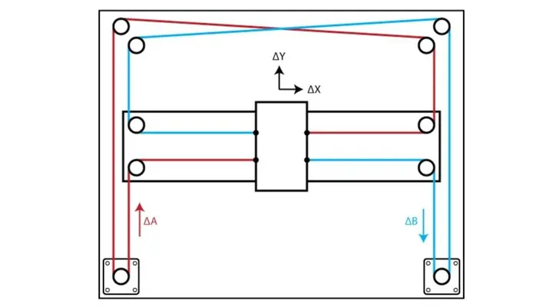

Figure 5 Working Mechanism

Table 11 Motor and Pen plotter Movement

|  |  |  |  |  |  |  |
| --- | --- | --- | --- | --- | --- | --- |
| **Motor L** | **Motor R** | **Direction** |  | **Motor L** | **Motor R** | **Direction** |
| ↺ | ↻ | **⇈** |  | ↺ | x | **↗** |
| ↻ | ↺ | **⇊** |  | x | ↻ | **↖** |
| ↺ | ↺ | **⇉** |  | x | ↺ | **↘** |
| ↻ | ↻ | **⥢** |  | ↻ | x | **↙** |

## 4.4 Program Code with Explanation

# CHAPTER 5: BILL OF MATERIALS AND FUTURE SCOPE

Summary: This chapter lists down all the components and their quantity used for this project.

## 5.1 Bill of Materials

The list mentioned below serves as a crucial reference providing a bill of materials with all the information about quantities, specifications and description of each item ensuring efficient manufacturing and assembly process.

|  |  |  |  |  |
| --- | --- | --- | --- | --- |
| Component No. | Component  Table 12 Bill of Materials  Name | Description of Component | Quantity | Type (MECH / Electrical) |
| 1 | Wooden Base Plate | Manufacturer: Holzland  Dimension: 305*305*15mm | 1 | MECH |
| 2 | Linear Ball Bearing | Manufacturer: Misumi  Inner Diameter: 6 mm  Outer Diameter: 12 mm  Length: 19 mm  Material: Stainless Steel | 6 | MECH |
| 3 | Timing Belt | T2 2mm pitch 6mm wide rubber | 2 | MECH |
| 4 | Shafts | D6 x 300mm | 3 | MECH |
| 5 | Side Support Left | For direction through vertical movement | 2 | MECH |
| 6 | Side Support Right | For direction through vertical movement | 2 | MECH |
| 7 | Main Support | For direction through horizontal movement | 2 | MECH |
| 8 | Pen Holder | To hold the pen and move horizontally | 1 | MECH |
| 9 | Main Support End | To fix guiding shaft | 1 | MECH |
| 10 | Pulley With Cap | To fix pulleys | 2 | MECH |
| 11 | Main Pulley | To guide the timing belts | 8 | MECH |
| 12 | Pulley Cap | To fix pulley | 8 | MECH |
| 13 | Bolts | M4 x 25  M4 x 16  M5 x 25 | 3  6  4 | MECH |
| 14 | Nuts | M3 | 4 | MECH |
| 15 | Box | To hold electrical components | 1 | MECH |
| 16 | Cover | To hold electrical components | 1 | MECH |
| 17 | Bread Board | Size: 166 * 54 * 10 mm | 1 | Electrical |
| 18 | Jumper Wires | Male to Male  Female to Female  Single Core |  | Electrical |
| 19 | DC motor | DAGU- DG01D 48.1- Mini DC Gearbox | 2 | Electrical |
| 20 | Thingspark ESP32 WROOM WRL 17361 | 4-pin JST Qwiic Connector  micro-B USB Connector  Operating Voltage: 2.3 to 3.6 V  Xtensa® Single-Core 32-bit LX6 Microprocessor | 1 | Electrical |
| 21 | Qwiic Motor Driver | Operates from 3 to 11 volts with 12V absolute max  3.3V default VCC and logic | 1 | Electrical |
| 22 | Push Button | D 15mm Length 24mm | 1 | Electrical |
| 23 | Micro Switch Red  (Limit Switch) | XSS-5GL 13  Operating Speed 0.1mm-1m/s | 4 | Electrical |
| 24 | Power Supply Unit  (QITA TS1171) | It can convert 7 - 11 V input to 3.3 or 5 V output. | 1 | Electrical |

## 5.2 Future Scope

* Make the pen plotter more versatile so that it can hold several different coloured pens or markers. You may then make colourful drawings and experiment with the potential of colour blending and gradients.
* Use of servo motors with encoder can increase the accuracy and precision of the motion or We can Also implement PID control for smooth control of motion.
* We can use GRBL Software which can not only draw Nikolaus’ house but can also draw different designs provided by user.